Enable the Blockchain to run nodes on separate devices

* Turn off Windows Firewall
  + Open up Windows Defender Firewall under the Control Panel
    - Click on System and Security

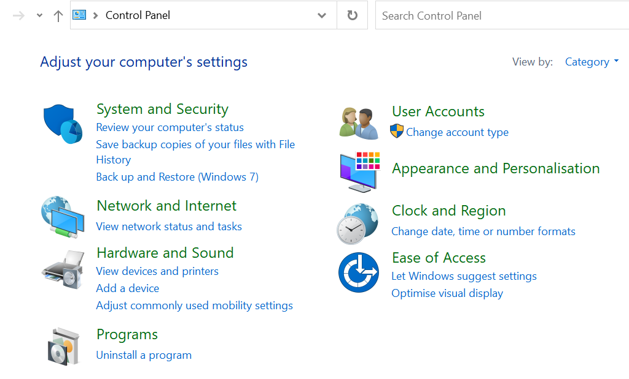

* + - Click on Windows Defender Firewall

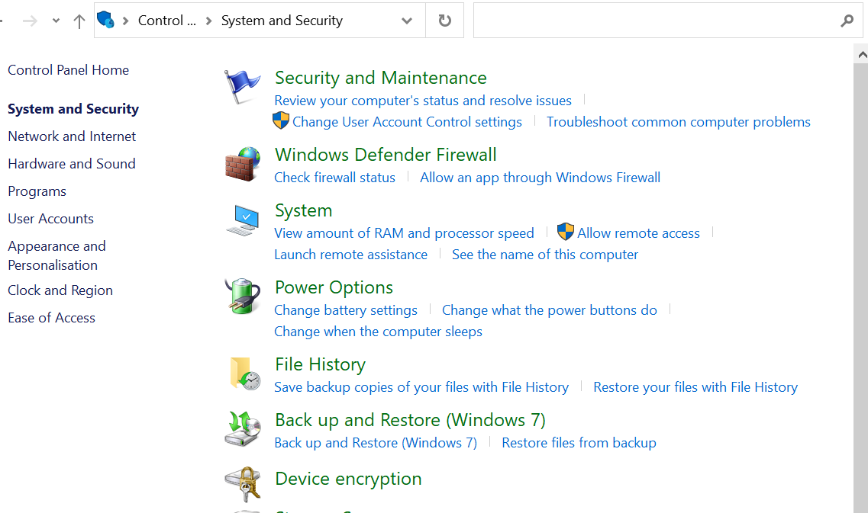

* + - Switch off Windows Firewall

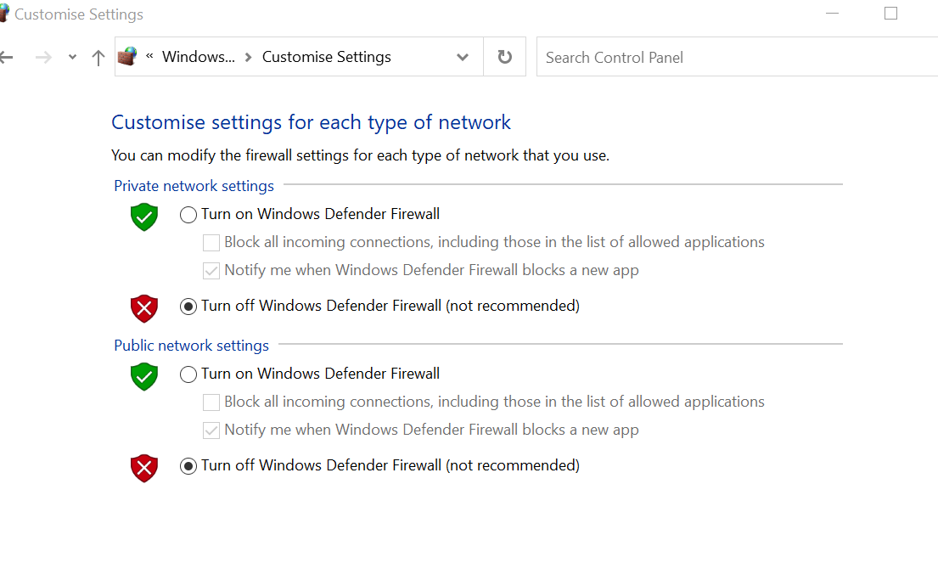

* Ping both Machines IP Addresses
  + Open up the command prompt and type the command ‘ipconfig’ and retrieve the IPV4 Addresses for both the host and the external machine

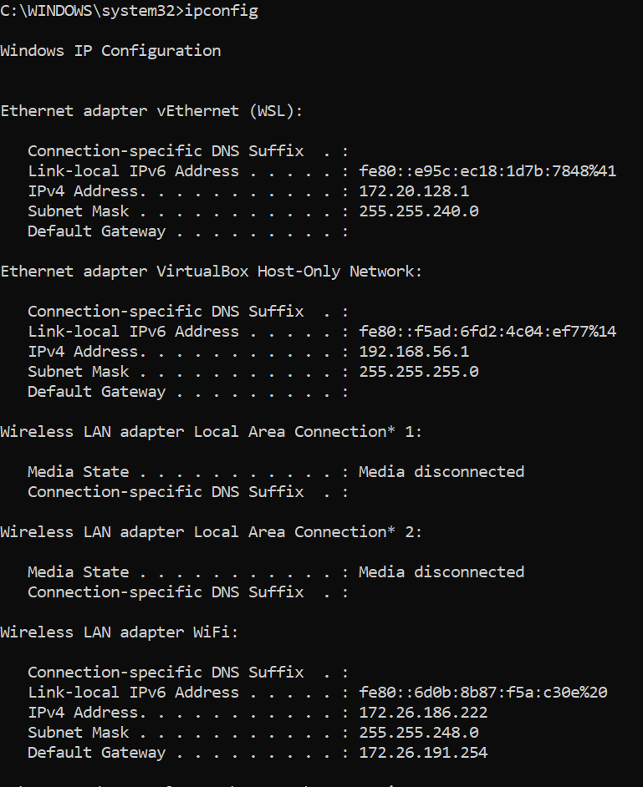

* + Ping both IP Addresses

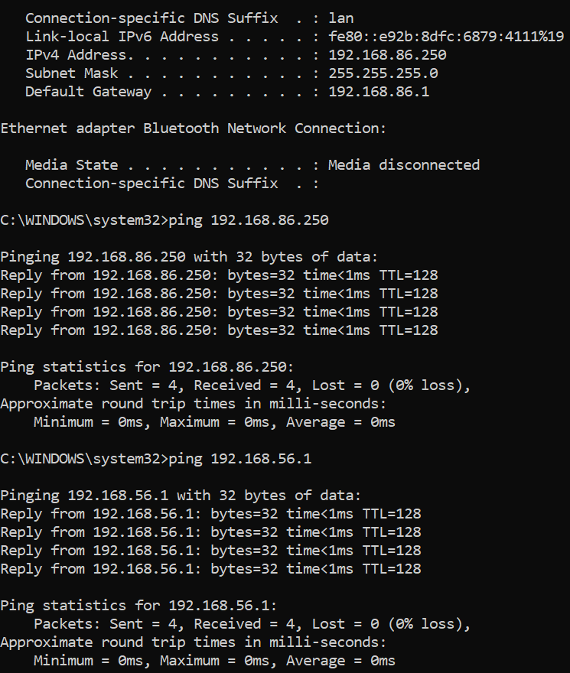

* Edit Besu Node’s Config Command with Host Machine’s IP Address
  + For this scenario, Nodes 1 and 2 will run on the Host Machine and Nodes 3 and 4 will run on the external device/computer
    - Run the following commands for Nodes 1 to 4:
      * Node 1:

besu **--data-path**=data **--genesis-file**=..\genesis.json **--rpc-http-host**=0.0.0.0 --rpc-http-enabled **--rpc-http-api**=ETH,NET,IBFT,EEA,PRIV **--host-allowlist**="*" **--rpc-http-cors-origins**="all" --privacy-enabled **--privacy-url**=http://127.0.0.1:9102 **--privacy-public-key-file**=Tessera\nodeKey.pub **--min-gas-price**=0 **--rpc-ws-enabled**=true **--rpc-ws-host**=0.0.0.0 **--rpc-ws-port**=9545

* + - * Node 2:

besu **--data-path**=data **--genesis-file**=..\genesis.json **--bootnodes**=enode://a32b7b959c0acc4fda78814f1261ab964b535a7e63f25f9fd149b391a016297c7f8b200b9e8a90790904ac0e68ff9c31c7fae63dca866a2e4080a314c7bebe86**@127.0.0.1:30303** **--p2p-port**=30304 **--rpc-http-host**=0.0.0.0 --rpc-http-enabled **--rpc-http-api**=ETH,NET,IBFT,EEA,PRIV **--host-allowlist**="*" **--rpc-http-cors-origins**="all" **--rpc-http-port**=8546 --privacy-enabled **--privacy-url**=http://127.0.0.1:9202 **--privacy-public-key-file**=Tessera\nodeKey.pub **--min-gas-price**=0 **--rpc-ws-enabled**=true **--rpc-ws-host**=0.0.0.0 **--rpc-ws-port**=9546

* + - * Node 3:

besu **--data-path**=data **--genesis-file**=..\genesis.json **--bootnodes**=enode://a32b7b959c0acc4fda78814f1261ab964b535a7e63f25f9fd149b391a016297c7f8b200b9e8a90790904ac0e68ff9c31c7fae63dca866a2e4080a314c7bebe86**@192.168.86.250** **--p2p-port**=30305 **--rpc-http-host**=0.0.0.0 --rpc-http-enabled **--rpc-http-api**=ETH,NET,IBFT,EEA,PRIV **--host-allowlist**="*" **--rpc-http-cors-origins**="all" **--rpc-http-port**=8547 --privacy-enabled **--privacy-url**=http://127.0.0.1:9302 **--privacy-public-key-file**=Tessera\nodeKey.pub **--min-gas-price**=0 **--rpc-ws-enabled**=true **--rpc-ws-host**=0.0.0.0 **--rpc-ws-port**=9547

* + - * Node 4:

besu **--data-path**=data **--genesis-file**=..\genesis.json **--bootnodes**=enode://a32b7b959c0acc4fda78814f1261ab964b535a7e63f25f9fd149b391a016297c7f8b200b9e8a90790904ac0e68ff9c31c7fae63dca866a2e4080a314c7bebe86**@192.168.86.250 --p2p-port**=30306 **--rpc-http-host**=0.0.0.0 --rpc-http-enabled **--rpc-http-api**=ETH,NET,IBFT,EEA,PRIV **--host-allowlist**="*" **--rpc-http-cors-origins**="all" **--rpc-http-port**=8548 --privacy-enabled **--privacy-url**=http://127.0.0.1:9402 **--privacy-public-key-file**=Tessera\nodeKey.pub **--min-gas-price**=0 **--rpc-ws-enabled**=true **--rpc-ws-host**=0.0.0.0 **--rpc-ws-port**=9548

* + - End Result:

